Fundamentals of Databases (CBIO204)
Spring, 2026

Biobank and Biospecimen Management System
Student: Youssef Hatem - 202000579

Introduction
BioBanker is a database for managing a small research biobank. The system keeps information about donors, consent, sample collection, storage, aliquots, researchers, test requests, and the use of stored material. The goal is to keep these records connected without repeating the same information in different places.
The project focuses on research biospecimen management rather than clinical diagnosis or patient treatment. All donor data in the project is synthetic and is used only for database demonstration.
Project Scope
• Manage donor records and research consent.
• Record sample collection events and sample types.
• Track freezer, shelf, and box storage locations.
• Manage samples and the aliquots created from them.
• Record researchers and their laboratory test requests.
• Connect samples to test requests through an associative table.
• Record sample usage and protect remaining aliquot volume.
Assumptions
• One current consent record is kept for each donor in this simplified version.
• Each sample belongs to one collection event, one sample type, and one current storage location.
• An aliquot belongs to one sample.
• The project uses synthetic donor and biospecimen data.
• The system focuses on research inventory and usage tracking.

Requirements And Business Rules
The following requirements define what the system should do. They are written separately from the database implementation so that the scope and rules are clear before looking at the SQL.
Requirement | What it means in the system | Main table(s)
Manage donors | Store a unique donor code and basic donor information. | DONORS
Record consent | Keep the current research-consent status for each donor. | CONSENT_RECORDS
Record collection | Store when, where, and by whom a collection event happened. | COLLECTION_EVENTS
Manage samples | Store sample type, storage location, collected volume, available volume, and quality status. | SAMPLES
Manage storage | Identify freezer, shelf, box, and storage temperature. | STORAGE_LOCATIONS
Manage aliquots | Track portions of samples and their remaining volume. | ALIQUOTS
Manage researchers | Store researchers who request or use samples. | RESEARCHERS
Manage test requests | Record request date, priority, purpose, and status. | TEST_REQUESTS
Connect samples and requests | Allow one request to use multiple samples and one sample to appear in multiple requests. | SAMPLE_TEST_REQUESTS
Record usage | Record the researcher, aliquot, date, volume used, and purpose. | SAMPLE_USAGE
Major Business Rules
• Donor, sample, researcher, and aliquot codes must be unique.
• Every foreign key must reference an existing parent record.
• Available sample volume cannot exceed collected volume.
• An aliquot's current volume cannot exceed its original volume.
• A test request belongs to one researcher.
• A sample can be linked to many test requests, and a request can use many samples.
• An aliquot cannot be used for more volume than it currently contains.
• A valid usage reduces the aliquot's remaining volume automatically.

Entity-Relationship Diagram (ERD)
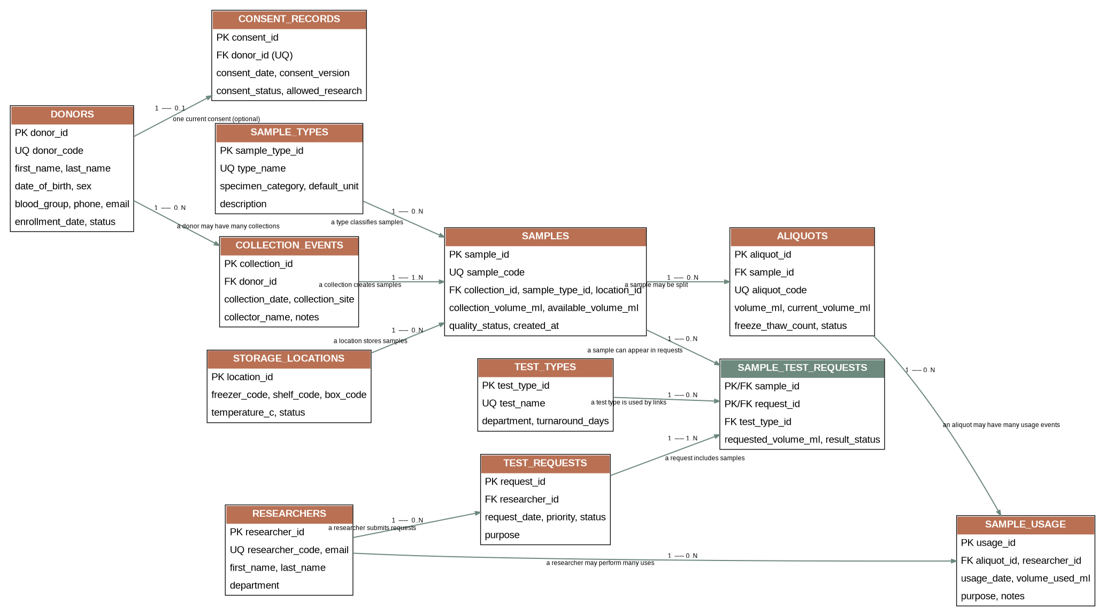
Fig. 1 Conceptual ERD for BioBanker. The diagram shows the main entities, primary/foreign keys, relationship names, and cardinality/participation labels such as 1, 0..1, 0..N, and 1..N.

The main M:N relationship is between SAMPLES and TEST_REQUESTS. It is resolved through SAMPLE_TEST_REQUESTS, which also stores relationship-specific attributes such as requested volume and result status.
Entities, Attributes, And Key Decisions
Entity | Main attributes | Key decision / purpose
DONORS | donor_id (PK); donor_code (UQ); first_name; last_name; date_of_birth; sex; blood_group; phone; email; enrollment_date; status | Keeps donor information. donor_code is the user-facing identifier.
RESEARCHERS | researcher_id (PK); researcher_code (UQ); first_name; last_name; department; email (UQ) | Stores researchers who submit requests or use samples.
CONSENT_RECORDS | consent_id (PK); donor_id (FK, UQ); consent_date; consent_version; consent_status; allowed_research | Simplified one-current-consent-per-donor model.
SAMPLE_TYPES | sample_type_id (PK); type_name (UQ); specimen_category; default_unit; description | Lookup table so sample-type information is not repeated in every sample.
COLLECTION_EVENTS | collection_id (PK); donor_id (FK); collection_date; collection_site; collector_name; collection_notes | Separates the event of collection from the sample record.
STORAGE_LOCATIONS | location_id (PK); freezer_code; shelf_code; box_code; temperature_c; status | Represents a physical storage position.
SAMPLES | sample_id (PK); sample_code (UQ); collection_id (FK); sample_type_id (FK); location_id (FK); collection_volume_ml; available_volume_ml; quality_status; created_at | Core biospecimen record.
ALIQUOTS | aliquot_id (PK); sample_id (FK); aliquot_code (UQ); volume_ml; current_volume_ml; freeze_thaw_count; status | Represents smaller portions of a sample.
TEST_TYPES | test_type_id (PK); test_name (UQ); department; turnaround_days | Lookup table for laboratory tests.
TEST_REQUESTS | request_id (PK); researcher_id (FK); request_date; priority; purpose; status | Stores research requests for laboratory work.
SAMPLE_TEST_REQUESTS | sample_id (PK/FK); request_id (PK/FK); test_type_id (FK); requested_volume_ml; result_status | Associative table resolving the M:N relationship.
SAMPLE_USAGE | usage_id (PK); aliquot_id (FK); researcher_id (FK); usage_date; volume_used_ml; purpose; notes | Stores actual use history for aliquots.

SCHEMA
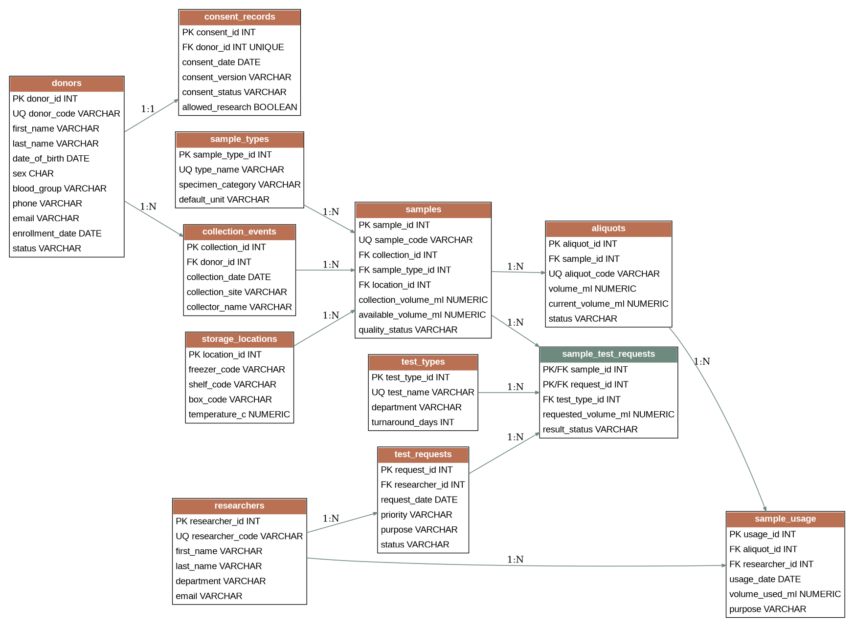
Fig. 2 Relational schema representation of the implemented database. The schema maps the ERD into tables with primary keys, foreign keys, and unique identifiers.
Key Relationships
• DONORS 1 : 1 CONSENT_RECORDS
• DONORS 1 : N COLLECTION_EVENTS
• COLLECTION_EVENTS 1 : N SAMPLES
• SAMPLE_TYPES 1 : N SAMPLES
• STORAGE_LOCATIONS 1 : N SAMPLES
• SAMPLES 1 : N ALIQUOTS
• RESEARCHERS 1 : N TEST_REQUESTS
• SAMPLES N : N TEST_REQUESTS through SAMPLE_TEST_REQUESTS
• ALIQUOTS 1 : N SAMPLE_USAGE
• RESEARCHERS 1 : N SAMPLE_USAGE

Normalization To 3NF
The database is designed to reach Third Normal Form (3NF). The main idea is to keep each fact in one suitable table and avoid repeating the same information in many rows.
1NF
The tables contain atomic values and each table has a primary key. For example, a DONORS row stores one donor code, one first name, one last name, and one email rather than a list inside a single field.
2NF
Non-key attributes depend on the whole key. This is especially important in SAMPLE_TEST_REQUESTS because its composite key is (sample_id, request_id). The requested volume and result status belong to that sample-request combination.
3NF
We separated related concepts into different tables. Sample type details are kept in SAMPLE_TYPES, storage details are kept in STORAGE_LOCATIONS, and researcher details are kept in RESEARCHERS. This avoids repeating those details in SAMPLES or TEST_REQUESTS.
Why This Design?
For example, if a freezer box changes its status, we update one STORAGE_LOCATIONS record instead of changing many sample rows. This reduces update problems and keeps the database easier to maintain.
DDL CODES
CREATE TABLE donors (
donor_id INTEGER PRIMARY KEY,
donor_code VARCHAR(20) NOT NULL UNIQUE,
first_name VARCHAR(50) NOT NULL,
last_name VARCHAR(50) NOT NULL,
date_of_birth DATE NOT NULL,
sex CHAR(1) NOT NULL CHECK (sex IN ('F','M','O')),
blood_group VARCHAR(3),
phone VARCHAR(20),
email VARCHAR(120) UNIQUE,
enrollment_date DATE NOT NULL,
status VARCHAR(15) NOT NULL DEFAULT 'ACTIVE'
);
CREATE TABLE samples (
sample_id INTEGER PRIMARY KEY,
sample_code VARCHAR(25) NOT NULL UNIQUE,
collection_id INTEGER NOT NULL REFERENCES collection_events(collection_id),
sample_type_id INTEGER NOT NULL REFERENCES sample_types(sample_type_id),
location_id INTEGER NOT NULL REFERENCES storage_locations(location_id),
collection_volume_ml NUMERIC(8,2) NOT NULL CHECK (collection_volume_ml > 0),
available_volume_ml NUMERIC(8,2) NOT NULL CHECK (available_volume_ml >= 0),
quality_status VARCHAR(15) NOT NULL DEFAULT 'ACCEPTED',
created_at DATE NOT NULL,
CHECK (available_volume_ml <= collection_volume_ml)
);
The full DDL is included in create_tables.sql. It creates all tables, keys, constraints, and indexes.

DDL CODES
CREATE TABLE sample_test_requests (
sample_id INTEGER NOT NULL REFERENCES samples(sample_id),
request_id INTEGER NOT NULL REFERENCES test_requests(request_id),
test_type_id INTEGER NOT NULL REFERENCES test_types(test_type_id),
requested_volume_ml NUMERIC(8,2) NOT NULL CHECK (requested_volume_ml > 0),
result_status VARCHAR(15) NOT NULL DEFAULT 'PENDING',
PRIMARY KEY (sample_id, request_id)
);
CREATE TABLE sample_usage (
usage_id INTEGER PRIMARY KEY,
aliquot_id INTEGER NOT NULL REFERENCES aliquots(aliquot_id),
researcher_id INTEGER NOT NULL REFERENCES researchers(researcher_id),
usage_date DATE NOT NULL,
volume_used_ml NUMERIC(8,2) NOT NULL CHECK (volume_used_ml > 0),
purpose VARCHAR(250) NOT NULL,
notes VARCHAR(250)
);
CREATE INDEX idx_samples_type ON samples(sample_type_id);
CREATE INDEX idx_samples_location ON samples(location_id);
CREATE INDEX idx_usage_aliquot ON sample_usage(aliquot_id);
The composite primary key in SAMPLE_TEST_REQUESTS prevents the same sample-request pair from being inserted twice.
DML CODES
The load script contains the project test data. Each main table has at least 10 meaningful rows, which is the minimum stated in the course guidelines.
Table | Rows in load_data.sql
DONORS | 10
RESEARCHERS | 10
CONSENT_RECORDS | 10
SAMPLE_TYPES | 10
COLLECTION_EVENTS | 10
STORAGE_LOCATIONS | 10
SAMPLES | 10
ALIQUOTS | 12
TEST_TYPES | 10
TEST_REQUESTS | 10
SAMPLE_TEST_REQUESTS | 11
SAMPLE_USAGE | 10
DML EXAMPLE
INSERT INTO donors VALUES
(1,'D001','Mariam','Hassan','1998-02-14','F','O+',
'01010000001','mariam.h@example.com','2025-09-01','ACTIVE');
INSERT INTO samples VALUES
(1,'SMP001',1,1,1,10,7,'ACCEPTED','2025-09-03');
INSERT INTO test_requests VALUES
(1,1,'2025-09-15','HIGH',
'DNA quality assessment for sequencing','PENDING');

SQL QUERIES
-- Retrieval
SELECT donor_code, first_name, last_name, status
FROM donors
WHERE status = 'ACTIVE'
ORDER BY donor_code;
-- Join
SELECT s.sample_code, d.donor_code,
st.type_name, sl.freezer_code
FROM samples s
JOIN collection_events ce ON ce.collection_id = s.collection_id
JOIN donors d ON d.donor_id = ce.donor_id
JOIN sample_types st ON st.sample_type_id = s.sample_type_id
JOIN storage_locations sl ON sl.location_id = s.location_id;
-- Aggregation
SELECT st.type_name, COUNT(*) AS sample_count,
SUM(s.available_volume_ml) AS total_available_volume
FROM sample_types st
JOIN samples s ON s.sample_type_id = st.sample_type_id
GROUP BY st.type_name;
-- Subquery
SELECT donor_code, first_name, last_name
FROM donors
WHERE donor_id IN (
SELECT ce.donor_id
FROM collection_events ce
JOIN samples s ON s.collection_id = ce.collection_id
JOIN aliquots a ON a.sample_id = s.sample_id
JOIN sample_usage su ON su.aliquot_id = a.aliquot_id
);
DATA MODIFICATION
INSERT INTO test_requests
(request_id, researcher_id, request_date, priority, purpose, status)
VALUES (11, 1, CURRENT_DATE, 'NORMAL',
'Database demonstration request', 'PENDING');
UPDATE test_requests
SET priority = 'HIGH'
WHERE request_id = 11;
DELETE FROM test_requests
WHERE request_id = 11;
Views And Advanced Database Object
VIEW 1 — sample_inventory

This view combines samples with donor, sample type, and storage information. It is useful when a user wants to see what material is available and where it is stored without writing the same joins each time.
VIEW 2 — pending_test_requests

This view shows pending or in-progress requests, the researcher, the priority, and the number of linked samples. It gives a simple view of the current laboratory workload.
TRIGGER — manage_aliquot_usage()

The trigger runs when a SAMPLE_USAGE record is inserted, updated, or deleted. Before an insert, it checks the aliquot's remaining volume. If the requested amount is too large, the insert is rejected. If the amount is valid, the remaining volume is reduced. Deleting a usage record restores the volume.

IF NEW.volume_used_ml > available THEN
RAISE EXCEPTION
'Insufficient aliquot volume. Available: %, requested: %',
available, NEW.volume_used_ml;
END IF;
UPDATE aliquots
SET current_volume_ml = current_volume_ml - NEW.volume_used_ml
WHERE aliquot_id = NEW.aliquot_id;
Test Cases and Testing Evidence

Clean Database Execution Order
create_tables.sql
triggers_procedures.sql
views.sql
load_data.sql
testing.sql
queries.sql
Limitations
- The consent model keeps one current consent record for each donor.
- The database uses synthetic data and does not contain real patient or clinical information.
- User accounts, permissions, audit logs, backups, and advanced security features are not included.
- The system focuses on sample management and research use, not patient diagnosis or treatment.
- A real biobank would also need additional monitoring and validation before being used in a production environment.
Conclusion
BioBanker provides a practical database for a small research biobank. The main workflow is represented from donor enrollment and consent through collection, storage, aliquoting, laboratory requests, and sample use.
The design uses separate tables for the main concepts, a many-to-many associative table for sample and test requests, and database constraints to protect the stored data. The trigger adds a useful business rule by preventing an aliquot from being over-used. The project also includes the SQL operations required for the database course: retrieval, joins, aggregation, subqueries, INSERT, UPDATE, DELETE, two views, and an advanced database object. The report documents the design decisions, normalization, test data, and testing plan.

